
Koneru Lakshmaiah Education Foundation
(Deemed to be University estd. u/s. 3 of the UGC Act, 1956)
Off-Campus: Bachupally-Gandimaisamma Road, Bowrampet, Hyderabad, Telangana - 500 043. Phone No: 7815926816, www.klh.edu.in

STUDENT CASE STUDY EXECUTION REPORT
Department | FED
Subject | DSA-2
Academic Year | 1-III Semester (2025-2026)
Faculty Name | Mohd.Razia Alangir Banu
Student Name | M.Geethika
Roll Number | 2520030485
Branch | CSE
Course Outcome | Apply BFS and DFS graph traversal algorithms and construct Minimum Spanning Trees using Kruskal's and Prim's algorithms to solve infrastructure design, network connectivity, and cluster analysis problems in weighted undirected graphs.

Case Study Topic: EduGraph – Adaptive Learning & Course Recommendation Platform
Work Done Summary:
Work Done Summary for CO3
Implemented BFS and DFS algorithms for course traversal and learning path analysis in the EduGraph platform. Applied Prim’s and Kruskal’s algorithms to create optimized course recommendation networks and improve connectivity analysis efficiently.
Implementation Details:
- Implemented BFS algorithm for level-wise traversal of course dependency graphs.
- Used DFS algorithm to explore learning paths and connected course structures.
- Represented courses and prerequisites using weighted graph structures.
- Applied Prim’s algorithm to generate minimum-cost course connectivity networks.
- Implemented Kruskal’s algorithm to construct optimized recommendation networks using Minimum Spanning Trees (MST).
- Achieved efficient graph traversal and optimized connectivity analysis with reduced processing complexity.

Result: Screenshots / Output
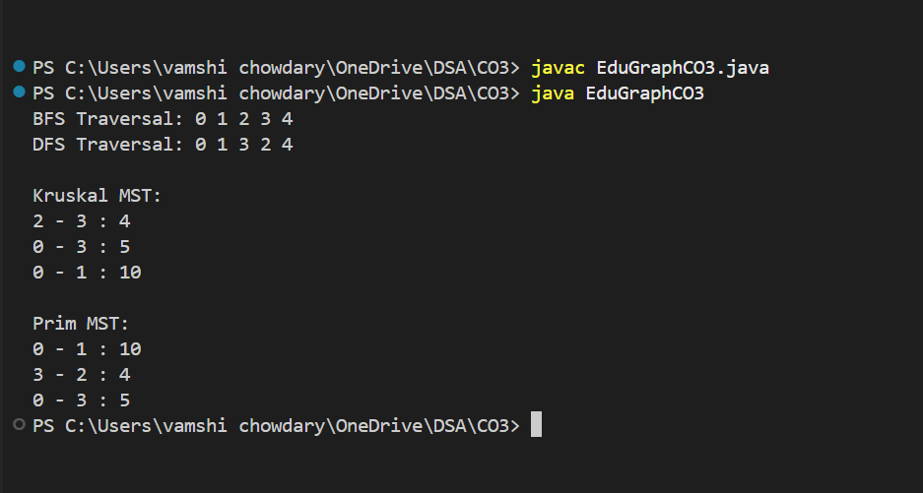

The implementation of BFS and DFS successfully traversed the course dependency graph and explored learning paths efficiently. Kruskal’s and Prim’s algorithms were used to construct Minimum Spanning Trees, creating optimized course recommendation networks with minimum connection cost. The project demonstrated effective graph traversal, network connectivity analysis, and graph optimization techniques in the EduGraph platform.
GitHub Link: https://github.com/geethika04-dot/DSA-2

Student Signature: Faculty Signature:

